Addresses and Directions
Onawa / Decatur Exit 112 on I-29

Super 8
2835 Iowa Ave N
Onawa, IA 51040
Located right off highway I-29

West Monona Middle / High School
1314 15th St
Onawa, IA 51040
Take Iowa Ave East off of highway, Turn right near Burgess Hospital

Onawa First Christian Church
722 15th St,
Onawa, IA 51040
From Iowa Ave: Go past Burgess Health Center / Hospital (Right side). 15th St is located on the next left. Church will be on the left hand side (1st Church on the left).

Sylvan Runkel State Preserve (Loess Hills Wildlife Management Area)
178th St. and Oak Ave., rural Castana
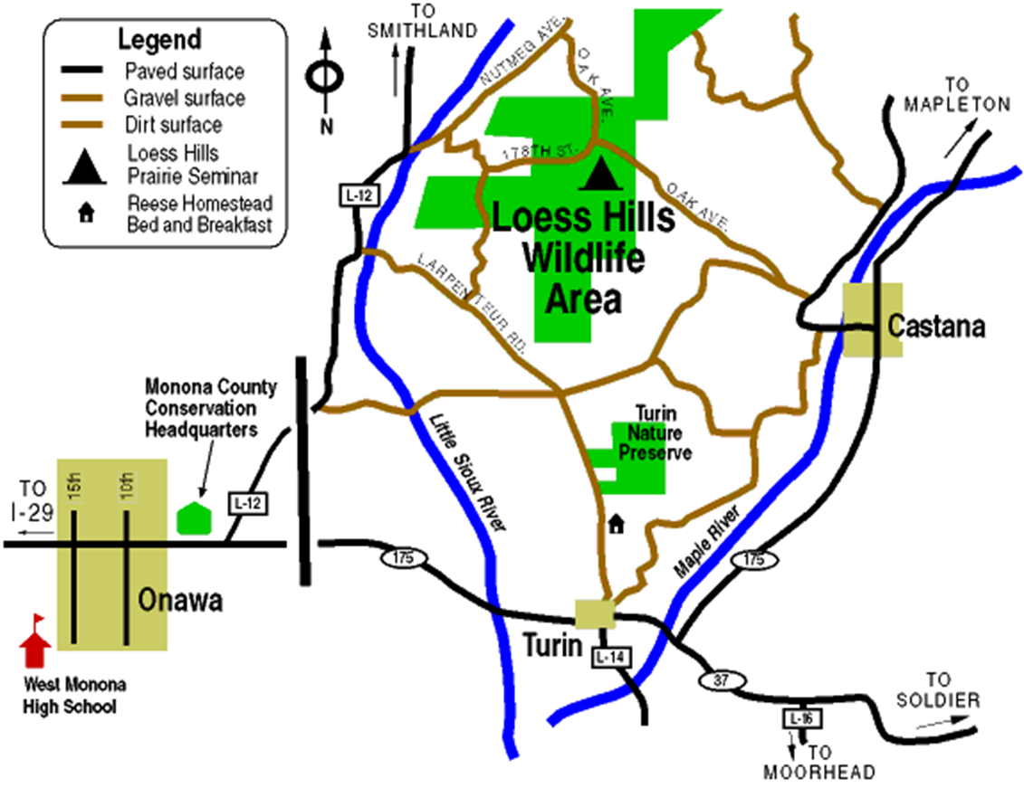

To get to the outdoor seminar site/campground from Onawa, travel east on Hwy 175 (which is Main St. in Onawa) to L-12. Turn north onto L-12 and travel 7.2 miles to Nutmeg Ave. Turn right and take Nutmeg Ave. 0.4 miles to the northeast across the Little Sioux River bridge and then turn right onto 178th St. Follow 178th St. for two miles and you will come to the Loess Hills Wildlife Management Area parking lot just before the intersection of 178th St. and Oak Ave.

